**The Conecte SUS: strategic advances for Brazilian Digital Health Transformation**

Gabriella Nunes Neves1, Elivan Silva Souza1,3, Joselio Emar de Araújo Queiroz1,2, Vitor Rocha de Araujo1, Larissa Gonçalves Mangabeira da Silva1, Blanda Helena de Mello1,2, João Marques Lopes Barbosa1,2, Laís Bié Pinto Bandeira1, Vanessa Lora1, Vinicius Colonese Mrad1, Vívian Furlan de Camargo Ramos Mendonça1, Walter da Silva Domingos1, Silmara Vieira da Silva1, Ligeíze Ferreira Lins1, Kelly Neves Pinheiro Brito1, Adriano Santiago Dias dos Santos1, Lara Liz Freire1,2, André Gustavo Souza dos Santos1, Thais Lucena de Oliveira1, Robson Willian de Melo Matos1, Paula Xavier dos Santos1,3, Jose Eduardo Bueno de Oliveira 1 and Ana Estela Haddad1,4

1 Department of Information and Informatics, Information and Digital Health Secretary, Brazil Ministry of Health, Brasília, Brazil; 2 University of Brasília; 3 Oswaldo Cruz Foundation (Fiocruz); 4 University of São Paulo (USP)

Corresponding Author: [gabriella.nunes@gmail.com](mailto:gabriella.nunes@gmail.com); [gabriella.neves@saude.gov.br](mailto:gabriella.neves@saude.gov.br); [datasus@saude.gov.br;](mailto:datasus@saude.gov.br) - DATASUS - Ministério da Saúde Esplanada dos Ministérios, Bloco G Edifício Anexo A 1º Andar CEP: 70058-900 Brasília-DF.

**ABSTRACT**

In this case study we describe the app and web application Conecte SUS as a strategic tool for the digital health transformation in Brazil. Since the technological boost brought by the COVID-19 epidemic, the Conecte SUS has become a superapp that combines multiple services in the healthcare area. In 2020, with the availability of information on COVID-19 and routine vaccines, the app became well-known and strengthened, with a remarkable 400% increase of new downloads and 233% increase of active users. In addition to vaccines data availability, we highlight the description of the Healthy Weight and Transplants mini-apps. As part of the efforts to unite and rebuild Brazil, initiated on 1 January 2023, the Brazilian government committed to an inclusive and sustainable growth agenda. Key federal government priorities include addressing hunger and inequality. Therefore, as future directions, Conecte SUS becomes an important component for expansion of access, gender, and ethnic-racial equity to the Unified Health System (SUS), like the Equity SUS mini-app and the Menstrual Dignity Program. Some challenges still need to be faced, such as digital inclusion, connectivity, and literacy to face social, regional, and technological inequalities. Altogether, the process of digital health transformation in Brazil is in full development.

**Key words:** Conecte SUS, Digital health, Health equity, Universal Access to Health Care Services, Public Health

**INTRODUCTION**

Besides being widely known for its continental size and for its cultural diversity, Brazil is historically characterized by an evident social inequality, exclusion, racism, and poverty. With three levels of government having economic, political, and administrative autonomy, Brazil’s federative structure currently has 5,570 municipalities with major differences in economic and administrative capacity, population density and territorial extension[1].

As the main structure in the healthcare area, the Brazilian Unified Health System (SUS) is recognized for being one of the most comprehensive and complex public health systems in the world, with the growing challenge of offering universal health coverage and integral and equitable healthcare to more than two hundred million citizens[2,3].

The organization of the regionalized and decentralized health care networks is one of the main challenges of the SUS, which requires a coordination and participative effort to share health care services between the different levels of government. The SUS provides primary care, urgent and emergency services, specialized and hospital care levels, epidemiological, sanitary, and environmental surveillance actions and services, and pharmaceutical assistance, with all these services benefiting from the implementation of digital health.

Heavily affected by COVID-19 pandemic, Brazil has advanced in the use of Information and Communication Technologies, increasing availability of the Internet and electronic systems for recording patient information, and the availability of patient electronic health record [4]. It is worth highlighting the creation of the Secretariat for Information and Digital Health, which expresses the importance of this agenda as a national public policy.

As a learning path, the country also has as a reference the 8 Guiding Principles of the Digital Transformation of the Health Sector of the Pan-American Health Organization (PAHO), seeking to guarantee connectivity in the health sector and accelerating towards inclusive digital health, giving emphasis on information security, the transversality of human rights in all stages of the digital transformation, and the citizen as the protagonist or with the citizen as the main focus of the strategy[5].

The 4th Priority of the Brazilian Digital Health Strategy (2020-2028), and of the National Policy of Information and Health Informatics (PNIIS), “*The User as Protagonist”* represents the aim of *engaging patients and citizens to promote the adoption of Digital Health for the management of their health, their family and their community* [6]. Knowing that citizen engagement is a global and intersectoral challenge, the Brazilian Ministry of Health (BMoH) through the Secretariat of Information and Digital Health, has been promoting activities in interface with different sectors, inside and outside the health field, such as Primary Care and Worker’s Health, the Brazilian Social Security Institute (INSS), the Ministry of Education and the Secretariat of Digital Government, to name a few. Many of these intersectoral partnerships focus on the use of data in health, having been the National Health Data Network (RNDS) and the Conecte SUS program important as a source and dissemination of information.

Conecte SUS has evolved over the last decade into a technological solution for the reliable availability of national electronic health records, health educational content and management of self-care in health. The National Health Data Network (RNDS) is the national interoperability platform, which aims to guarantee access to health data, providing continuity of care for citizens[6].

In this case study, we describe the Conecte SUS and its main features, highlighting the given access to COVID-19 and routine vaccination data. We further describe challenges for citizen engagement, and the Conecte SUS potential as a tool to support facing social and health inequalities in Brazil. Finally, we share future perspectives and what we are planning for the coming years.

**THE CONECTE SUS**

The Conecte SUS is an evolution of the SUS Digital Card, launched in 2015, and “Meu DigiSUS” application, dated 2017, which in turn provided access to the National Health Card (CNS), our health identification which carry some sociodemographic data. It was common that in each government, the health app would have its name changed, giving the brand of the leaders of the moment. Major deal is that Conecte SUS is on a path to be turning into structural and solid healthcare public good.

The first release of Conecte SUS was launched in 2020, marking the beginning of a process of increased downloads and the maintenance of its app name, which brings the idea of connecting services and citizens. In 2021, in the beginning of the COVID-19 vaccination, the number of Conecte SUS users reached the milestone of over 24.2 million downloads. This was further expanded by the availability of the COVID-19 National Vaccination Certificate, so that by 2022, the application reached over 33.8 million downloads. With the challenge of facilitating access to health services and information, the Conecte SUS is expanding its functionalities and ensuring comprehensive and scalable continuity of care, bringing the population even closer to the continuous development of SUS.

The health data presented in the RNDS is made available on Conecte SUS so that users can securely access their own health information in an easily and friendly way. Conecte SUS is the official application of the Brazilian Ministry of Health (BMoH) and serves as the gateway to digital services of Brazilian healthcare system. We have a maxim that says: *Conecte SUS allows citizens to track their healthcare history in the palm of their hand*.

The Conecte SUS also issues documents such as the National Vaccination Card, National and European Union Digital COVID-19 Certificate, COVID-19 laboratory test results and National Health Card. Moreover, it presents medications provided by the “Programa Farmácia Popular do Brasil”[1], as well as presents the citizen's position on the waiting list of the National Transplant System. Additionally, it enables citizens to identify healthcare establishments near their location based on the type of service needed.

Citizen engagement with Conecte SUS has been enhanced through features such as displaying laboratory test results and recording COVID-19 vaccinations. The main feature has been the vaccine records area which provides the vaccination history, including COVID-19 vaccines and other routine vaccinations. Starting from 2022, all vaccines records received by the federal level are available in RNDS, in an interoperable format and displayed for citizens.

The app can be downloaded on any device or directly through the Conecte SUS website[2]. The registration and login process for the application is carried out using the GOV.BR Portal, where the information is loaded from RNDS data. The Portal gov.br brings together all the information and services of the Federal Government, which in recent years has consistently advanced towards digital transformation. The Brazilian Individual Taxpayer Registration (CPF) has become the single key for locating citizens' information in the Federal Public Administration systems, and Portal gov.br also allows digital public services to be offered in a unified channel, facilitating citizen access.

The 2022 new version of Conecte SUS introduces the concept of mini-apps launching new and multiple applications/services into one platform. We highlight two of them: a) Healthy Weight mini-app which provides a 12-week journey to promote the creation of healthy habits based on proper nutrition and physical activity; and b) Transplants mini-app, which provides secure information about the organ donation process in Brazil and, most importantly, real-time monitoring of your position in the queue of the National Transplant System to citizens waiting for a procedure. The mini apps enable the scalability of Digital Health, allowing the centralization of health applications for the user in one place.

The superapp operates in Progressive Web Apps (PWA), a technological development methodology aimed at leveraging the resources of both native apps and web. They offer advantages such as the development of a single code that can run on various platforms and operating systems, as they are executed by the web browsers of devices. Web applications have also become accessible even offline, managing communication between the applications. In addition, Conecte SUS has a technology that avoids the consumption of high levels of memory in cell phones. This allows all applications hosted on the main application not to compromise cell phone storage, meeting the concerns raised by SUS users.

**Facing Covid-19: Vaccination records and digital certificates**

In 2019, the Conecte SUS program was in the pilot project phase carried out in the state of Alagoas when the COVID-19 pandemic started. As a result, the program changed its priority axis to the implementation of strategies and emergency actions for the management of the pandemic crisis within the scope of the program, re-planning the goals of the pilot project [7].

In this sense, RNDS in Brazil was quickly elevated to the position of national repository of COVID-19 data, seeking to allow health care establishments, health professionals and citizens to share health information, promoting prevention and health care with more quality. In early 2022, in the wake of the international dialogue on border control and International Certificates of COVID-19 Vaccination, the BMoH began negotiations with the European Commission (EC) to promote the interoperability of certificates, along the lines of European regulation.

In September 2022, the EC carried out tests that demonstrated that the COVID-19 vaccination certificates issued by Brazil, in accordance with the RNDS, were interoperable with the trust regime established by the EC Regulation, allowing the verification of its authenticity, validity and integrity. In October 2022, the Certificate Equivalence Decision was published.

Considering the already established adoption of the national certificate at the time, Brazil decided to make both certificate standards available in the Conecte SUS application: the one that already existed for citizens in national territory and the standard of equivalence with the European Union. The latter, for citizens traveling to the 80 countries and territories connected to the European gateway, in addition to versions in Portuguese, Spanish and English.

This achievement brought direct benefits to traveling citizens, facilitating the procedures for verifying vaccination against Covid-19 in cases where the vaccination certificate was still maintained as a health requirement for entry into the countries. In addition, it represented one of the first international interoperability actions carried out by Brazil in digital health.

Considering the Conecte SUS program from its inception in May 2020, by the BMoH Ordinance No. 1434, of 2o May 2020[3], a notable significant variation in the number of users and downloads of the Conecte SUS application is evident, illustrating the pronounced impact caused by the COVID-19 pandemic. Particularly noteworthy is the increase observed in January 2021 (21J), coinciding with the beginning of vaccination campaigns and the subsequent display of information within the application. During this period, the number of new downloads escalated from 232,000 to over one million, representing a remarkable 400% increase from one month to the next. Similarly, the number of active users surged from 423,000 to 1.4 million, resulting in a substantial 233% increase, as depicted in Figure 1.

Another pivotal aspect is the progressive accumulation of users over time. While it is evident that the application's use was driven by the pandemic, it is crucial to emphasize its continuous significance, which exhibited substantial utilization. This underpins the notable surge in new downloads, which began in May 2020 with just over 78,000 and reached 3.6 million by December 2021. Furthermore, it is noteworthy that the number of monthly active users rose from 23,900 to 10.0 million in January 2022, representing the period of highest active user engagement (Figure 1).

Lastly, the accumulated increase in downloads deserves emphasis, having undergone a trajectory of substantial growth since July 2021, culminating in over 41.3 million downloads by August 2023 (Figure 1).

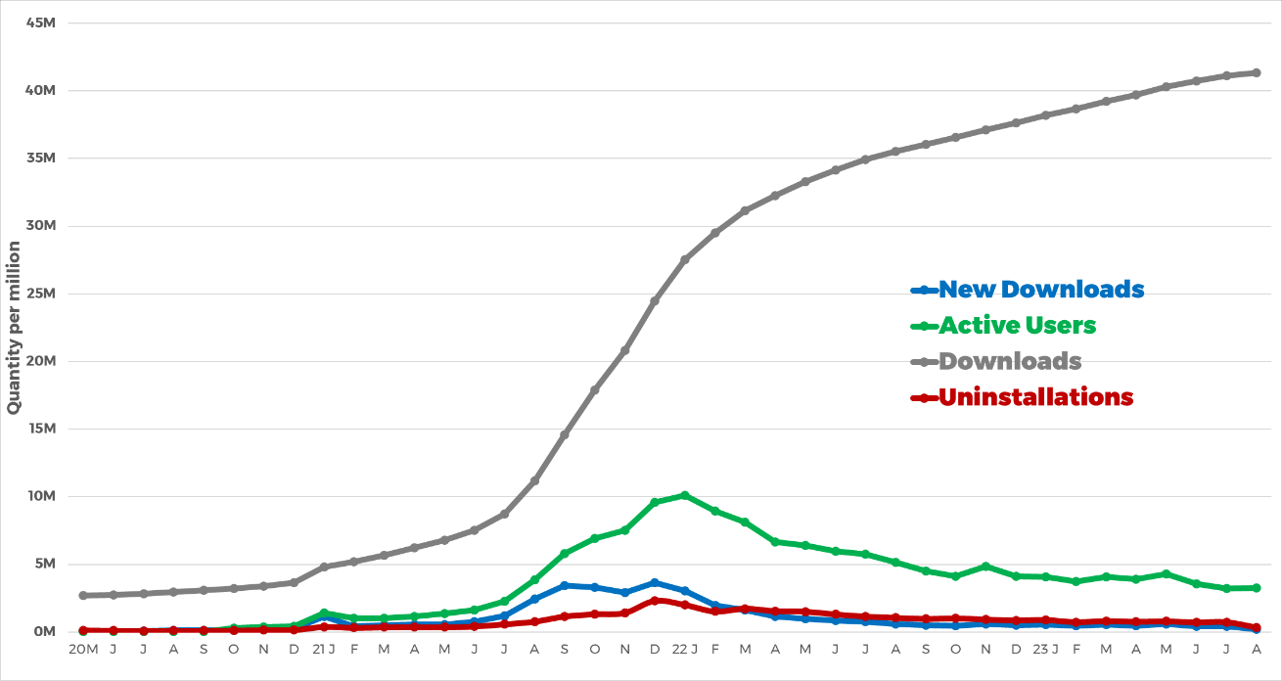**Figure 1. Cumulative quantity of monthly downloads, count of monthly active users, and cumulative quantity of downloads of the Conecte SUS application, spanning from May 2020 (20M) to August 2023 (23A)**.

Notes: New Downloads: Downloads carried out by users who had not previously used the application; Active Users: Users who accessed the application at least once in the month (Monthly Active Users - MAU); Downloads: Accumulated count of the total application downloads.

As demonstrated by the functionalities of Conecte SUS, which advocates for utility, accessibility, and citizen autonomy concerning their health, the capacity to issue relevant clinical documents is unmistakably underscored. This capacity stands out prominently, especially within the context of the pandemic, which marked the beginning of these functionalities. A concrete example is observed in the figure below, where over 1.2 million COVID-19 vaccination certificates were issued in the month of functionality deployment, i.e., December 2021 (21D), alongside 646,000 issuances of digital vaccination records during the same period.

Unquestionably, the COVID-19 pandemic has acted as a pivotal catalyst in driving the demand for certificate issuances among citizens, resulting in over 5.0 million documents being issued solely in January 2022 (22J). However, it is intriguing to note the shifting behavioral pattern over time, with more issuances of digital vaccination records than COVID-19 vaccination certificates in June, July, and August 2023. Furthermore, growth in the quantity of International Certificate of Vaccination or Prophylaxis for Yellow Fever (ICVP-YF) issuances is observed since its inception in December 2022, starting with three issuances in that month and a noteworthy escalation to 5.6 thousand issuances in August of the same year (Figure 2).

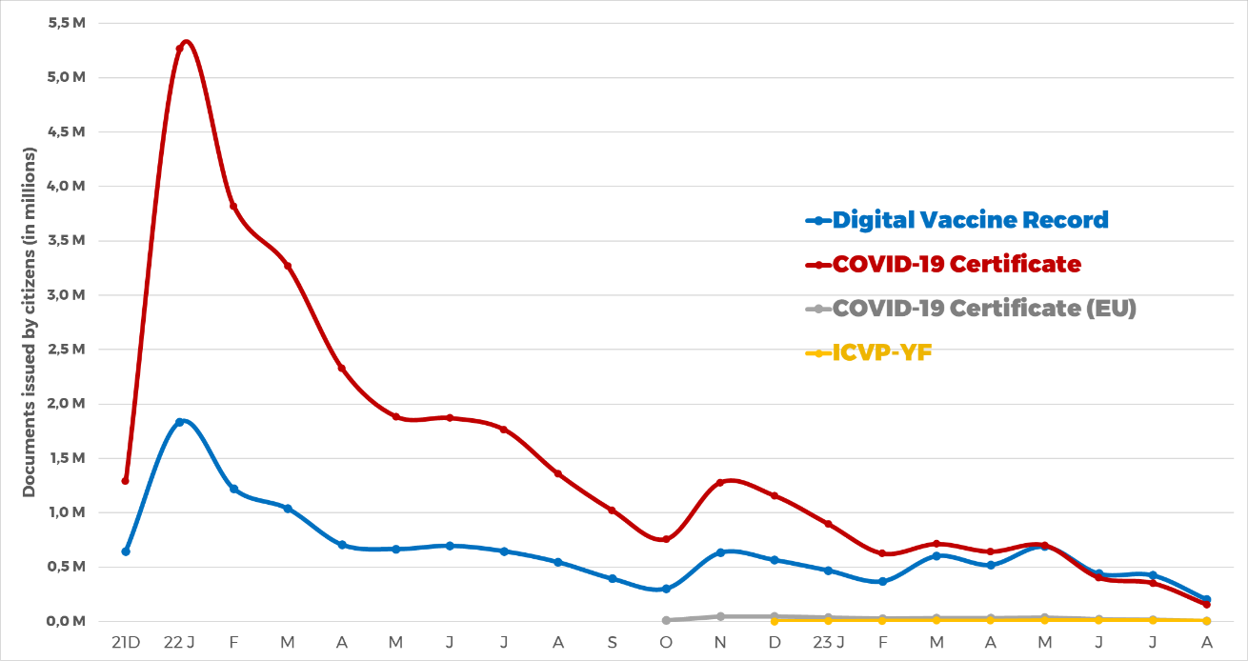

**Figure 2. Quantity of documents issued by Conecte SUS, segmented by document type, spanning from December 2021 (21D) to August 2023.**

Notes: Digital Vaccination Record: document presenting the citizen's vaccination history; COVID-19 Certificate: citizen's COVID-19 vaccination certificate; COVID-19 Certificate (EU): COVID-19 vaccination certificate for citizens of the European Union; ICVP-YF: International Certificate of Vaccination or Prophylaxis for Yellow Fever.

This scenario accentuates that the urgency imposed by the pandemic played a pivotal role in advancing digital health in the country, propelling the swift adaptation and expansion of Conecte SUS capabilities. This program has matured to furnish new citizen-centric functionalities, embodying a significant tool in overcoming accessibility barriers while underscoring the central role of citizens in their health management. Moreover, this approach fosters a culture of individual empowerment in health matters. The progressive provision of information and services within Conecte SUS, encompassing from examination records to clinical histories of treatments and hospitalizations, not only attests to the efficacy of undertaken actions but also indicates an enduring potential for growth and refinement of this integrated platform.

The progressive provision of information and services within Conecte SUS, encompassing from examination records to clinical histories of treatments and hospitalizations, not only attests to the efficacy of undertaken actions but also indicates an enduring potential for growth and refinement of this integrated platform.

**Healthy Weight mini-app**

The prevalence of obesity and nutritional deficiencies has gained significant prominence in the contemporary demographic landscape. In this context, the promotion of a healthy diet and regular physical activity emerges as pivotal factors in the pursuit of effective solutions. The relationship between overweight, obesity, and the incidence of various severe chronic diseases has garnered considerable attention in the realm of healthcare [8].

Consequently, the quest for comprehensive and effective universal health coverage stands as a global aspiration that demands attention to various priorities. Among these, the promotion of healthy aging stands out as an intrinsic component. In this vein, the utilization of tools that seek to ensure access to high-quality physical and mental information and practices has emerged as a priority for health management organizations benefiting from digital services [9].

A noteworthy feature of the application is the capacity for users to self-record their weight and height information. This functionality provides users with the opportunity to monitor their personal progress, thereby establishing a record that highlights the impact of dietary choices and physical activity over time. Consolidating itself as an important mechanism for promoting health and including citizens in self-care, favoring therapeutic adherence and engagement in important actions to reduce morbidity and mortality.

**Transplants List mini-app**

Transplantation is characterized by the replacement of organs, tissues, or cells with end-stage failure in a recipient, with healthy grafts derived from a donor. The primary aim of transplantations is to enhance the quality of life and the survival of patients suffering from severe illnesses, injuries, or medical conditions that impact the functionality of a specific organ or tissue [10].

Among global scenarios, the Brazilian donation and transplantation program stands out as possibly one of the most comprehensive, positioning itself as one of the largest public programs in the world. Its distinctive feature lies in the equitable allocation of organs, devoid of social or cultural privileges, thus solidifying an exemplary logistical system. However, a disconcerting disparity persists between the escalating demand for organ transplants and the actual capacity for execution, both in Brazil and in other nations. As reported by the BMoH, current data reveal a waiting list for transplant procedures that has surpassed the 65,000-patient mark in Brazil. Among these patients on the waiting list, particular attention is drawn to the specific list for renal transplants, with a significant contingent of approximately 37,000 individuals awaiting the opportunity [11,12].

In this context, aiming to enhance accessibility to data and procedures for both pre-transplant and post-transplant patients, the BMoH has developed, within the Conecte SUS platform, the Transplants application. This innovative application has established direct patient access to the database of the National Transplant System (SNT) through its functionalities, providing citizens with their active position on the waiting list, allowing direct and transparent status monitoring, enabling geolocation of authorized transplant facilities, and offering content with guidance on the donation and transplantation process.

This initiative embodied in this technological tool, demonstrates a genuine effort towards democratizing information, with the goal of empowering patients and providing a comprehensive and participatory understanding of all aspects of the donation and transplantation journey.

**FUTURE DIRECTIONS**

The digital transformation in health has been fast, accelerated, and has expanded in recent years, mainly since the COVID-19 pandemic. While it is taking place on a widespread basis, digital health also has its gaps and inequalities. The Conecte SUS app, in turn, has the mission of filling these gaps and making digital health services more accessible and equitable.

Aligned with the guidelines of the newly created Secretariat of Information and Digital Health in the BMoH, the future of Conecte SUS has equity, human rights, and social inclusion as values, permanently considering accessibility, economic issues and the democratization of health. In this perspective, we will launch a new mini-app and a new feature that follow this path: the Equity SUS mini-app and the Menstrual Dignity application.

**Equity SUS mini-app**

The mini-app Equity SUS is an application for the National Program for Equality of Gender, Race, Ethnicity and Valorization of SUS Workers[4] and it’s a collaborative initiative between the SEIDIGI and the Secretariat for Management of Health Work and Education. In Brazil, women represent most of the workforce in the health sectors. In the public network alone, there are more than 2.1 million women, which represents 74% of the workforce in the SUS [13]. It is worth mentioning that Nísia Trindade Lima is the first woman to head the Brazilian Ministry of Health from January 2023.

The actions foreseen by the program will expand the necessary conditions for the practice of equity. The expectation is that the SUS Equity application will be part of the daily lives of citizens and SUS workers, designed by active listening, making sure the app meets the real needs of the target public. The application was developed collaboratively, through a workshop with the participation of workers and users of the SUS, including indigenous representatives, quilombolas, the LGBTQIAP+ community, leaders of social movements and health managers.

The mini-app aim gives information, documents, research that allow workers, managers and citizens to identify situations of violence, prejudice and discrimination within the scope of the SUS, as well as to have access to reporting channels and information about the care networks that help and protection to SUS worker women.

**The Menstrual Dignity**

Conecte SUS will be the official application of the Menstrual Health Protection and Promotion Program[5]. An exclusive mini-app will be created where it will be possible to issue an authorization for the removal of sanitary pads in establishments accredited by the Popular Pharmacy Program in Brazil. To issue the authorization, the citizen must be a person who menstruates and be classified in at least one of the requirements: a) are of low income and are enrolled in public schools; b) are homeless or in a situation of extreme social vulnerability; c) are collected in units of the prison system; or d) are following socio-educational measures[14].

Ensuring gender equity and all women's rights is a priority for the current federal government. Based on the well-known current Brazilian scenario of poverty, where approximately 13.6 million inhabitants (about 6.5% of the population) live in extreme poverty, the BMoH will ensure the supply of pads by the SUS, focusing on the population below the poverty line.

**CITIZEN ENGAGEMENT CHALLENGES**

Among the rising wave of ICT adoption in Brazil, a distinct set of challenges arises that significantly shape citizens’ experiences. With a population characterized by diversity and varying educational levels, the role of communication becomes paramount, necessitating the use of simplified language and educational initiatives that facilitate comprehensive understanding. The concept of eHealth literacy, encompassing users’ capacity to search, comprehend, and assess health-related information via ICT platforms, emerges as a primary hurdle that must be surmounted to foster citizen engagement[15].

The issue of inequalities in internet access across different regions further compounds this complex scenario. As indicated by the 2022 ICT Home survey, within the 20% of the population without internet connectivity, 14% reside in rural areas. Additionally, this study underscores the pronounced economic barriers, with vulnerable population accounting for a substantial 53% of the populace without access to the internet [15].

Allocating financial resources to bolster the promotion, education, and accessibility of these technologies is indispensable to broaden their adoption. Moreover, ensuring effective governance and offering comprehensive features assumes critical importance in terms of securing the confidence and appeal of digital solutions among citizens. The consistent monitoring of digital tool use, coupled with user surveys, occupies a central role. This proactive strategy furnishes invaluable insights into authentic user requisites and effectively steers enhancements. Additionally, research is essential to bridge knowledge gaps and stimulate innovation, thereby yielding solutions that are not only effective but also tailored to the population’s unique demands.

To overcome these multifaceted challenges, a collaborative strategy is imperative, requiring the concerted involvement of governmental bodies, the private sector, academic institutions, and civil society. By adopting a holistic perspective and jointly tackling these barriers, it becomes possible to usher in an era of more comprehensive and impactful adoption of digital health tools throughout Brazil.

**CONCLUSIONS**

In this case study, particular emphasis was placed upon the Conecte SUS initiative and its principal features, thereby illustrating its deployment as an information dissemination platform concerning COVID-19 vaccination and assorted health metrics. This underscores its role as a foundational construct in the establishment of Brazilian Digital Health transformation. Additionally, it discerns itself as a pivotal instrument in the Brazilian populace's endeavor to address socio-health disparities, whilst concurrently facilitating access and ensuring the continuity of healthcare provisions.

The Conecte SUS assumes the form of an application that serves to enhance the transparency of healthcare information. This encompasses demographic data, while simultaneously buttressing participatory requisites in a manner consonant with democratic principles and entailing social oversight. Such an approach is undertaken with the objective of reinforcing the tenets of the SUS and duly acknowledging the citizenry as primary stakeholders. Notwithstanding, it is imperative to elucidate the inherent challenges associated with furnishing nationwide connectivity and infrastructural support, whilst also proffering avenues for intervention within the purview of digital literacy and endeavors concerning stakeholder engagement and communicative strategies.

**ACKNOWLEDGMENTS:**

We are extremely grateful for all employees who work or have worked at Department of Information and Health Informatics (DATASUS). Special thanks to our Secretary of Information and Digital Health Ana Estela Haddad for welcoming and appreciating the importance and strength of the RNDS and Conecte SUS.

**AUTHORS’ CONTRIBUTIONS:**

All certify that they have participated sufficiently in the work to take public responsibility for the content, including participation in the concept, writing or revision of the manuscript.

**CONFLICT OF INTEREST:** none declared.

**REFERENCES**

1. Miranda, Wanessa Debôrtoli de, et al. Health inequalities in Brazil: proposed prioritization to achieve the Sustainable Development Goals. Cadernos de Saúde Pública 2023, 39/e00119022.
2. Ichihara MY, Ferreira AJF, Teixeira CSS, Alves FJO, Rocha AS, Diógenes VHD, et al. Mortality inequalities measured by socioeconomic indicators in Brazil: a scoping review. Rev Saude Publica. 2022, 56, 85.
3. Malta DC, Teixeira RA, Cardoso LSM, Souza JB, Bernal RTI, Pinheiro PC, et al. Premature mortality due to noncommunicable diseases in Brazilian capitals: redistribution of garbage causes and evolution by social deprivation strata. Rev Bras Epidemiol, 2023, 26/e230002.
4. Survey on the use of information and communication technologies in Brazilian healthcare facilities: ICT in Health 2022. Núcleo de Informação e Coordenação do Ponto BR. São Paulo: Comitê Gestor da Internet no Brasil, 2023.
5. Pan American Health Organization. PAHO. "Eight Guiding Principles of Digital Transformation of the Health Sector." A Call to Pan American Action 10 (2021). <https://iris.paho.org/handle/10665.2/54256> (28 August 2023, date last accessed)
6. Brazil. Ministry of Health. Executive Secretariat. SUS Computer Department. Brazilian National Digital Health Strategy 2020-2028 [electronic resource] / – Brasília: Ministry of Health, 2020; <https://bvsms.saude.gov.br/bvs/publicacoes/strategy_health_digital_brazilian.pdf> (28 August 2023, date last accessed)
7. Brasil. Ministério da Saúde. Secretaria Executiva. Departamento de Informática do SUS. Relatório Final do Projeto Piloto Conecte SUS : análise dos avanços obtidos entre outubro/2019 e junho/2020 [recurso eletrônico] / Ministério da Saúde, Secretaria Executiva, Departamento de Informática do SUS. – Brasília : Ministério da Saúde, 2020.
8. World Health Organization. (2020). Obesity and overweight. Retrieved from <https://www.who.int/news-room/fact-sheets/detail/obesity-and-overweight> (28 August 2023, date last accessed)
9. Thirteenth General Programme of Work 2019−2023 [Internet]. [citado 28 de agosto de 2023]. Disponível em: <https://www.who.int/about/what-we-do/thirteenth-general-programme-of-work-2019---2023> (28 August 2023, date last accessed)
10. Pestana JM. A pioneering healthcare model applying large-scale production concepts: Principles and performance after more than 11,000 transplants at Hospital do Rim. Rev Assoc Med Bras (1992). 2016 Oct;62(7):664-671. doi: 10.1590/1806-9282.62.07.664. PMID: 27925047.

<https://pubmed.ncbi.nlm.nih.gov/27925047/>

1. Soares LSDS, Brito ES, Magedanz L, França FA, Araújo WN, Galato D. Solid organ transplantation in Brazil: a descriptive study of distribution and access inequalities across the Brazilian territory, 2001-2017. Epidemiol Serv Saude. 2020 Apr 3;29(1):e2018512. English, Portuguese. doi: 10.5123/S1679-49742020000100014. PMID: 32267298. <https://pubmed.ncbi.nlm.nih.gov/32267298/> (28 August 2023, date last accessed)
2. Aubert O, Yoo D, Zielinski D, Cozzi E, Cardillo M, Dürr M, et al. COVID-19 pandemic and worldwide organ transplantation: a population-based study. Lancet Public Health. outubro de 2021;6(10):e709–19. <https://www.thelancet.com/journals/lanpub/article/PIIS2468-2667(21)00200-0/fulltext> (28 August 2023, date last accessed)
3. Ministry of Health holds first workshop of the National Program for Gender, Race and Valuation of Female Workers in the SUS.

<https://www.gov.br/saude/pt-br/assuntos/noticias/2023/julho/ministerio-da-saude-realiza-primeira-oficina-do-programa-nacional-de-equidade-de-genero-raca-e-valorizacao-das-trabalhadoras-no-sus> (30 August 2023, last accessed)

1. Decree No. 11.432, 8 March 2023.

<https://www.planalto.gov.br/ccivil_03/_ato2023-2026/2023/decreto/d11432.htm> (30 August 2023, last accessed)

1. Souza, Nicole Fajardo Maranha Leão de. eHealth literacy among young people: an exploratory study on the role of socioeconomic conditions in the use of health information on the Internet. 195 f. Thesis. Instituto de Comunicação e Informação Científica e Tecnológica em Saúde, Fundação Oswaldo Cruz, Rio de Janeiro, 2020. (Portuguese)
2. iCT Households 2022. Núcleo de Informação e Coordenação do Ponto BR. São Paulo: Comitê Gestor da Internet no Brasil, 2023.

1. The “Programa Farmácia Popular do Brasil” is a Federal Program that provides medicines used in Primary Health Care, through a partnership with private pharmacies and drugstores accredited in the program.
2. Conecte SUS Cidadão, the citizen Portal: <https://conectesus-paciente.saude.gov.br/login>
3. BMoH Ordinance nº 1.434, of 20 May 2020: <https://bvsms.saude.gov.br/bvs/saudelegis/gm/2020/prt1434_01_06_2020_rep.html> (28 August 2023, date last accessed)
4. Established by ordinance No. GM/MS 230, of March 7, 2023: [https://www.in.gov.br/en/web/dou/-/portaria-gm/ms-n-230-de-7-de -mar-2023-468487936](https://www.in.gov.br/en/web/dou/-/portaria-gm/ms-n-230-de-7-de%20-mar-2023-468487936)
5. The Program for the Protection and Promotion of Menstrual Health will, in accordance with Decree No. 11.432, of March 8, 2023, distribute sanitary pads free of charge and on a continuous basis to people who menstruate.